**Learn Math through Virtual Reality**

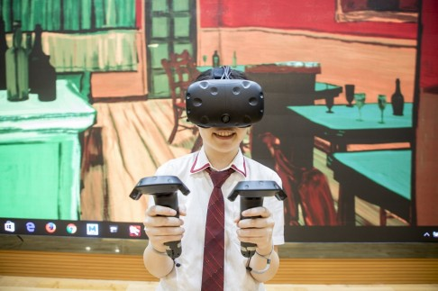

**Prepared by**

**Mariam Zikaria**

**Priyam Patel**

**Dhruv Patel**

**Mohammad Hasan**

**for use in CS 440**

**at the**

**University of Illinois Chicago**

**Spring 2017**

**Table of Contents**

How to Use This Document 2

List of Figures 9

List of Tables 10

I Project Description 12

1 Project Overview 12

2 The Purpose of the Project 12

2a The User Business or Background of the Project Effort 12

2b Goals of the Project 12

2c Measurement 13

3 The Scope of the Work 13

3a The Current Situation 13

3b The Context of the Work 14

3c Work Partitioning 16

3d Competing Products 18

4 The Scope of the Product 18

4a Scenario Diagram(s) 18

4b Product Scenario List 19

4c Individual Product Scenarios 19

5 Stakeholders 19

5a The Client 19

5b The Customer 20

5c Hands-On Users of the Product 20

5d Priorities Assigned to Users 21

5e User Participation 22

5f Maintenance Users and Service Technicians 22

5g Other Stakeholders 22

6 Mandated Constraints 23

6a Solution Constraints 24

6b Implementation Environment of the Current System 25

6c Partner or Collaborative Applications 25

6d Off-the-Shelf Software 26

6e Anticipated Workplace Environment 27

6f Schedule Constraints 28

6g Budget Constraints 28

7 Naming Conventions and Definitions 29

7a Definitions of Key Terms 29

7b UML and Other Notation Used in This Document 30

7c Data Dictionary for Any Included Models 30

8 Relevant Facts and Assumptions 31

8a Facts 31

8b Assumptions 32

II Requirements 33

9 Product Use Cases 33

9a Use Case Diagrams 33

9b Product Use Case List 34

9c Individual Product Use Cases 35

10 Functional Requirements 35

11 Data Requirements 36

12 Performance Requirements 38

12a Speed and Latency Requirements 38

12b Precision or Accuracy Requirements 39

12c Capacity Requirements 39

13 Dependability Requirements 40

13a Reliability Requirements 40

13b Availability Requirements 40

13c Robustness or Fault-Tolerance Requirements 41

13d Safety-Critical Requirements 42

14 Maintainability and Supportability Requirements 43

14a Maintenance Requirements 43

14b Supportability Requirements 43

14c Adaptability Requirements 44

14d Scalability or Extensibility Requirements 44

14e Longevity Requirements 45

15 Security Requirements 45

15a Access Requirements 45

15b Integrity Requirements 46

15c Privacy Requirements 47

15d Audit Requirements 48

15e Immunity Requirements 48

16 Usability and Humanity Requirements 48

16a Ease of Use Requirements 48

16b Personalization and Internationalization Requirements 50

16c Learning Requirements 51

16d Understandability and Politeness Requirements 52

16e Accessibility Requirements 52

16f User Documentation Requirements 53

16g Training Requirements 54

17 Look and Feel Requirements 54

17a Appearance Requirements 54

17b Style Requirements 55

18 Operational and Environmental Requirements 56

18a Expected Physical Environment 56

18b Requirements for Interfacing with Adjacent Systems 56

18c Productization Requirements 57

18d Release Requirements 58

19 Cultural and Political Requirements 58

19a Cultural Requirements 58

19b Political Requirements 59

20 Legal Requirements 60

20a Compliance Requirements 60

20b Standards Requirements 61

III Design 61

21 System Design 61

21a Design goals 61

22 Current Software Architecture 63

23 Proposed Software Architecture 63

23a Overview 63

23b Class Diagrams 63

23c Dynamic Model 63

23d Subsystem Decomposition 64

23e Hardware / software mapping 64

23f Data Dictionary 64

23g Persistent Data management 64

23h Access control and security 64

23i Global software control 65

23j Boundary conditions 65

24 Subsystem services 65

25 User Interface 65

26 Object Design 65

26a Object Design trade-offs 65

26b Interface Documentation guidelines 66

26c Packages 66

26d Class Interfaces 66

IV Test Plans 66

27 Features to be tested / not to be tested 66

28 Pass/Fail Criteria 66

29 Approach 67

30 Suspension and resumption 67

31 Testing materials ( hardware / software requirements ) 67

32 Test cases 67

33 Testing schedule 67

V Project Issues 68

34 Open Issues 68

35 Off-the-Shelf Solutions 68

35a Ready-Made Products 68

35b Reusable Components 69

35c Products That Can Be Copied 69

36 New Problems 70

36a Effects on the Current Environment 70

36b Effects on the Installed Systems 70

36c Potential User Problems 70

36d Limitations in the Anticipated Implementation Environment That May Inhibit the New Product 71

36e Follow-Up Problems 71

37 Tasks 72

37a Project Planning 72

37b Planning of the Development Phases 72

38 Migration to the New Product 73

38a Requirements for Migration to the New Product 73

38b Data That Has to Be Modified or Translated for the New System 73

39 Risks 74

40 Costs 75

41 Waiting Room 76

42 Ideas for Solutions 77

43 Project Retrospective 77

VI Glossary 78

VII References / Bibliography 78

VIII Index 78

### ****List of Figures****

Figure 1- Business Event List ………………………………………………………………… 12

Figure 2- Use Case Diagram ………………………………………………………………….. 13

# 

# Project Description

## Project Overview

A brief description of the product to be produced, before getting into details.

A virtual reality based program that educates children on elementary topics such as basic arithmetic, colors, and shapes.

## The Purpose of the Project

### The User Business or Background of the Project Effort

Our group has decided to create a virtual reality based product to educate young children. This product will be compatible with an HTC Vive. This program will be able to be downloaded onto a computer with a high-definition graphic card. Graphics using Unity 3D will need to be made, in a setting where virtual reality applications can be tested using controllers and screens. Our project was inspired by nostalgic memories of playing with wood blocks as children. It also reminded us of cartoon shows where questions would be asked, and we would have to wait years to answer like Dora the Explorer and Blues Clues. This product will be available for download online, and be marketed towards young parents.

Motivation

The motivation for this project is to provide a program that will teach kids what was once taught to us on educational television shows, but with much more interaction, creating a more realistic experience for the child. This would allow children to learn quicker, and be more independent in their thinking.

Considerations

In certain cases, where children have children disabilities, the problem is very serious, and these children need special attention and time to learn new things. Our application will help kids with learning disabilities as well, because it is making learning fun, and the children will be able to incorporate education with “real-life”.

### Goals of the Project

The real reason for this project is to make education fun for little kids and more interactive.

### Measurement

The main goal of this project is the give the users i.e. the children between age 5 – 8 and interactive way of learning. The main target audience for this software would be grade schools and customers with kids between that age who has HTC VIVE or Oculus Rift. This project has a lot of potential since we can replace from having extra teachers in the class to this automation which just requires a person

Initially we will try to demo it in few grade school and get reviews from the kids and teacher and depending on the response we can either modify or make more changes. This is to make sure we have a good understanding of what the main product should look like.

## The Scope of the Work

### The Current Situation

This product will be used in an educational environment such as a school or tutoring center. It will change the existing processes in schools by requiring kids thought the world getting same level of educational foundation. This product will be used instead of teachers giving students individual attention to learn, which will change the education system in schools and tutoring centers. Since it is meant for grade school students for now, it will have a bigger audience not only in sates but thought out the world. Especially, in the developing or undeveloped countries where kids don’t have the access to good education resources.

### The Context of the Work

Some external people that we would need to be involved in this project are graphics designers, HTC, and an A/V team to help us with any technical issues that arise during our set up and testing of our project. The core of this project will



Figure – Context Diagram

### Work Partitioning

Business Event List

Event Name Input and Output Summary

|  |  |  |
| --- | --- | --- |
| 1. Graphic Designer | Creates the graphics for the game (in) | Designs the elements that the user will interact with in the game. |
| 2. User Interaction with the shapes | Front end(in) | Makes sure that the user interface is easy to interact with |
| 3. VR Designer | Creates Visuals(in) | Makes sure that everything is in the right place |
| 4. Artist | Draws pieces (in) | Makes the drawings of the game pieces with the designer |
| 5. Score to keep track of activity | Scoring(out) | Records the scoring for teachers and for students’ progress |
| 7. A/V Technician | Setup (in) | Maintaining and making changes and sets up HTC vive |
| 8. HTC Vive System | System Update(out) | Updates the system in real time. |

### Competing Products

There are some educational games out there like Jigsaw Puzzle, letter blocks and more but they’re not in VR form. You can’t interact with those games. They are used for educational purposes but are not used classroom settings. To make sure that the product is being used to its fullest potential and it meets all the requirement for kids to educate themselves. The game is going to be design with the help of child psychologist and a lot of research will go behind the actual game to make sure that the users are benefiting from it and getting the education they need.

## The Scope of the Product

This project will include various sensors that will interact with the movement of the children. These movements will be captured and analyzed to update correctly the program. Some external entities that will interact with our product, aside from the users, will be the camera and sensors. There will be a controller that the users will have. This will directly show the hand movements and interactions by the user with the program. Our hardware will be HTC Vive using the Unity engine for the creation.

### Scenario Diagram(s)

There will be one main scenario that will occur that is playing the game,

Primary Actors:

Student/Child

Teacher

Preconditions:

VR Set up and teacher has access to the lesson plan

Basic Flow:

Set up lesson

Initiate and set up game

Play game

Collect and Review data

Alternative Flow:

Invalid teacher lesson

Child incorrectly interacts with product

Collect and Review data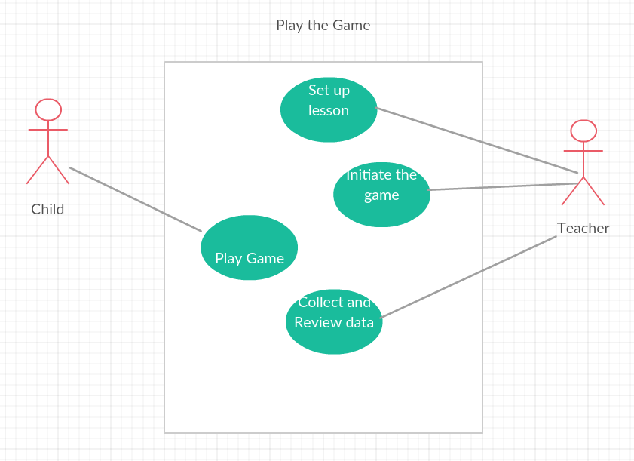

Figure 2 – Use case Diagram

### Product Scenario List

Teacher log in and set up lesson

Initiate lesson and send it for using by Children

Users will play the game

Level 1

Different Math Games

Level 2

Different Math Games

Level 2

Different Math Games

Level 3

Different Math Games

Level 4

Different Math Games

Level 5

Different Math Games

Collect data

Analyze data

### Individual Product Scenarios

**VR Gaming**: During the day, Mary has included in her daily lessons a time for VR learning. This entails setting up a classroom lecture, math level 1. These are kindergarten students who are learning how math works. So they need to have their lesson plans set out for them. The kids will come into class and put their VR headsets in their special room so that the sensors and video cameras will record and analyze the work that they do. They will

## Stakeholders

### The Client

A client for our product is an institution for educating children. This product can be used for grade school children but it can be expanded to middle school and high school by adding content to the product. But as of right now since we are focusing on grade school students. Hence, following are the names of our clients around Chicago area.

* Mundelein community grade school
* Stevenson grade school

The client role in this project is going to be specifying the school curriculum and to provide their budget and system description on which they are planning to host the application. This application uses room space; the client is also supposed to have a dedicated space.

### The Customer

A client for our product is an institution for educating children. This product can be used for grade school children but it can be expanded to middle school and high school by adding content to the product. But as of right now since we are focusing on grade school students. Hence, following are the names of our clients around Chicago area.

* Mundelein community grade school
* Stevenson grade school

To meet the client or the customer’s requirement the project will require the help of professionals who understand the need to educate grade level students and their psychology. We shall also provide a month free trail which will include the entire set to test how the students responded and if it is in the client’s interest to buy this product.

### Hands-On Users of the Product

● User name/category: Schoolchildren

● User role: Use the virtual reality game, participate in the activities and answer questions

● Subject matter experience: The children playing this game will be beginner users, new to the game. So, novice.

● Technological experience: Being children, they will have exposure to other children games and technology such as iPad and iPhone games. So, novice.

● Other user characteristics: This game is meant for children who are in preschool through fifth grade. There will be a variety of difficulty levels and topics that range from adding and subtracting, to division and multiplication. Age group and grade level will play into factor in choosing the difficulty level. Children with learning disabilities are the motivation in a virtual reality educational game such as this one, because they have a chance to learn math beyond simply looking at numbers and symbols.

Some users we have incorporated into our project are the HTC Company, because we are using their HTC Vive device and have to keep up with the HTC Vive System Updates and be in communication regarding the device when troubleshooting. We also have a Graphic Designer as a user because they are in charge of the visuals and animations required for this project. Another user, the Audio/Visual (A/V) Team, will be in contact with us to help set up the device, and help us in times of technical issues.

### Priorities Assigned to Users

Key User: Graphic Designer

Secondary User: A/V Technician, HTC

Unimportant user: N/A

The focus group for these products are education institution. More specifically it will be the grade school and middle schools. Since our product currently focuses on content for small kids, the plan is to get the feedback from the users i.e. the kids and see how they respond to it. If this turns out to be successful and helps the kids, we will try to incorporate more content. Since grade school students are good at picking things up when they play and also their content being the addition of content or update.

### User Participation

As from the client side it will be necessary for institution or academies to give the descriptions of their course work. The client would need to have a dedicated space and have an instructor to learn the technology and can supervise students while they are using the product. They also need a server with GPU of Nvidia GeFOrce GTX970, or AMD Radeon R9 290 equivalent or greater and HTV Vive which will be either provided with the software or can also be order and a client technician can set up for them.

### Maintenance Users and Service Technicians

HTC Vive is a product which will need some technical knowledge to set-up and installation for the program. Since the targets user are grade school students, we want to make sure it is a same environment for them. This device which is HTC Vive will require maintain ace and some technical some technical training to set up the device.

### Other Stakeholders

● Educational Experts (Teachers)

We require a team that will be decimated for helping the teacher in the institute to set up the product and learn the set-up of the application and how to monitor a user’s i.e. the student’s progress based on the score.

● Testers

The Testers are a group of grade school students who will be examining the software and giving us feedback.

● Business analysts

Come up with different or better business solutions. Also, responsible for getting the client requirement in term of technical requirement to the Project Manager.

● Technology experts

Technology are the developers who take the business technical requirement from the Project Manager. They must also be in constant contact with the Graphic Designer because of the usability and functional requirement that they will have to consider while designing.

● System designers

The systems designers are the electrical engineer that will help set HTC Vive.

● Marketing experts

We must have a marketing team that will be responsible foe the Online and Television advertisement.

● Legal experts

The legal experts are there to assist the company when in time of a contract signing or dealing with any legal matters.

● Graphic Designer

The Graphics designer will be responsible for the animation and the shapes, text and objects that will be involved in the game. They will also be in constant contact with the developers and projects managers to get the right specifics of the system before they start designing.

* Child Psychologist

Child Psychologist are a vital part of this project since we must understand how the kids respond in the application and what will be the right amount of challenge question should be added in the content and what changes we can make to the application.

(1) Easy to use functionality: Make sure that the AI system and the visuals are easy on the eyes and not too confusing to navigate through

* + - 1. Teacher controlled: The teacher has autonomy on the lessons administered and graded
      2. Friendly colors: this is strictly in the visuals. Needs to be child friendly and not intense
      3. Common sense understanding: the UI needs to be in a common sense method. No complex “clicks” to get to the end result.
      4. Understanding the logic behind the code: When coding or writing out the design of the project to use. There are certain logical designs that need to be implemented. This is why the Unity engine is used to make the proper systematic approach in the construction. This will pair perfectly with the HTC Vive.
      5. Stabilization: With the use of HTC Vive, we need to account for the camera set up. Due to many different technologies out there, we need to limit our spending and cost. This requires us to invest in a stabilizing camera, so a stable environment can be rendered for the children. Stabilization is important for the spotting and interaction notice from the users.
      6. A safe environment: Since our product requires a room to be built and set up in a manner that is geared towards the product, we would need to make sure that those accessing the room are not at risk. This would require us to invest in gold plated wiring, wall mounting rotating cameras. The walls would need to be fitted with foam and soft material.

Examples

Description: Users will use the head piece and the controllers to interact with the product in a stable room fitted with body recognizing cameras.

Rationale: The room is necessary for the data to be read and registered in an accurate manner

Fit criterion: All movements will be analyzed and registered to give the users the best experience

Description: The cameras will need to be fitted to be stable and view the student from all angles. This will mean that the room needs to have multiple cameras to see all angles.

Rationale: This is because any shaking will cause the body of the user to be distorted and the program will not register the movements properly.

Fit criterion: The Product will be HTC Vive exclusive.

Description: The product shall be a hand-held device. HTC Vive will be the product our software will work with efficiently

Rationale: This product is being marketed to children and schools. A software technology that is child friendly and school safe is something we need to gear towards.

Fit criterion: The product shall be made to fit the HTC Vive requirements, such as using high graphic cards and having the proper technology.

### Implementation Environment of the Current System

The product will be installed on hand held devices, owned or lent to schools, that will have the software and the capability to interact with the HTC Vive.

### Partner or Collaborative Applications

Computers, green screens, cameras to monitor activity, etc. A computer is required for the HTC Vive application, but because it is a high definition virtual reality device, a special graphic card will be needed for the computer to ensure proper visuals We will also need to use Unity 3D, Microsoft Visual Studio, and blender which will be used by the graphic designer and the programmers.

### Off-the-Shelf Software

This software can also be distributed off-the-shelf so that it can be used as any commercial software and be ready to us. But to use this software the machine or system on which this is application will be hosted should meet the minimum requirement of being able to run certain graphic. This program will be able to be downloaded onto a computer with a high-definition graphic card. Graphics using Unity 3D will need to be made, in a setting where virtual reality applications can be tested using controllers and screens.

### Anticipated Workplace Environment

The work place for this project must be at least 10 ft x 10 ft room so that the HTC Vive can be set-up

Also there should always be a trainer teacher monitoring the user and keep track of the progress.

### Schedule Constraints

Content

Have a working prototype by the beginning of a school year, and then have a product released by mid-year. So there is so level of hype that is created

Motivation

Having something to show by the beginning of the year gives us working data and tweaks we can make before releasing something substantial

Considerations

The deadline for a product release would be the end of a calendar year. But the testing product can be released for secure testing by users at the beginning of a school year

● What happens if we don’t build the product by the end of the calendar year?

● What is the financial impact of not having the product by the beginning of the Christmas buying season?

* Is there a leeway if the product cannot be released for testing by the beginning of the school year?

We do plan to have the product demoed initially to the client and depending on the

### 

### Budget Constraints

If the product is too expensive for the users to get into their schools, then that will defeat the purpose of supplying it to them.

## Naming Conventions and Definitions

### Definitions of Key Terms

HTC Vive: This is a VR headset that will provide the kids an interact way of learning.

Controllers: These controller will track the users gesture and perform the necessary task.

Unity 3D: This is a 3D modeling software that will be used by the Graphic Designer to make the shapes more appealing and content more interesting.

### UML and Other Notation Used in This Document

This document generally follows the Version 2.0 OMG UML standard, as described by Fowler in [4]. Any exceptions are noted where used.

## Relevant Facts and Assumptions

### Facts

The HTC Vive game uses Blender, Unity 3D, and HTV Vive software for application development and its interactive feather helps student learn faster.

### Assumptions

The main assumption is that the combination of the software’s will work.

To run the appropriate graphics for this application the customers system must have the appropriate situation.

# Requirements

## Product Use Cases

This section begins to describe in more specific and precise detail exactly what steps the system takes in the course of its performance. Use cases serve not only to more specifically define the system ( and its boundaries ), but also to identify functional requirements, to identify initial objects / classes, and to organize the work.

### Use Case Diagrams

Use Case diagrams serve two purposes: As a form of graphical table of contents listing the individual use-cases, and also to define the boundary of what is included as part of the proposed system and what is not included.

A use case diagram identifies the boundaries between the users (actors) and the product. You arrive at the product boundary by inspecting each business use case and determining, in conjunction with the appropriate stakeholders, which part of the business use case should be automated (or satisfied by some sort of product) and what part should be done by the user. This task must take into account the abilities of the actors (section 3), the constraints (section 4), the goals of the project (section 1), and your knowledge of both the work and the technology that can make the best contribution to the work.

The use case diagram shows the actors outside the product boundary (the rectangle). The product use cases are the ellipses inside the boundary. The lines denote usage. Note that actors can be either automated or human.

Depending on the complexity of the product it may be necessary to use more than one diagram to list all of the use cases. When more than one diagram is required the use-cases can be divided up several ways: Normal operations versus exceptional cases, or daily tasks versus monthly tasks, or user tasks versus administration tasks, etc.

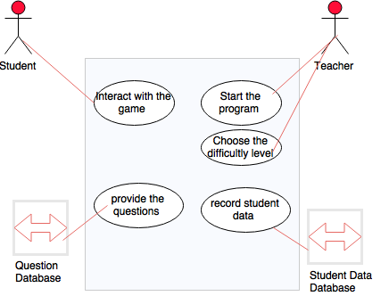

## Functional Requirements

Content

A specification for each functional requirement. As with all types of requirements, use the requirements shell*.* A full explanation is included in this template’s introductory material.

Motivation

To specify the detailed functional requirements for the activity of the product.

Examples

Each functional requirement should have a fit criterion or a test case. In any event, the fit criterion is the benchmark to allow the tester to determine whether the implemented product has met the requirement.

## Data Requirements

Content

A specification of the essential subject matter, business objects, entities, and classes that are germane to the product. It might take the form of a first-cut class model, an object model, or a domain model. Alternatively, these requirements might be described by defining the terms in the dictionary described in section 5.

Motivation

To clarify the system’s subject matter, thereby triggering recognition of requirements not yet considered.

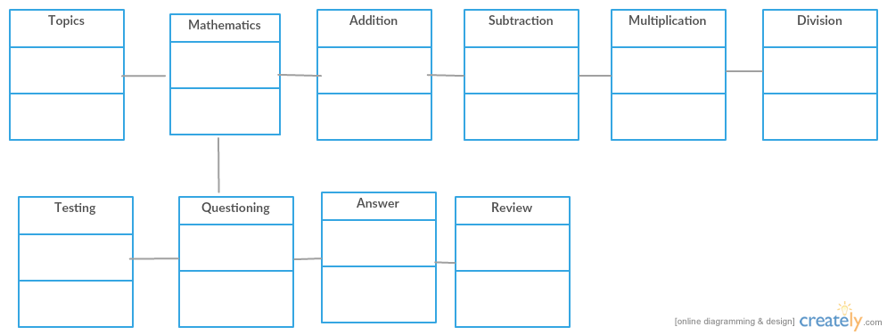

## Performance Requirements

### Speed and Latency Requirements

Content

Specifies the amount of time available to complete specified tasks. These requirements often refer to response times. They can also refer to the product’s ability to operate at a speed suitable for the intended environment.

We will have time constraints on answering questions based on the mathematical questions given to the children. The time the child takes to answer questions will be recorded, and there will be a timer to implement this.

Motivation

Some products—usually real-time products—must be able to perform some of their functionality within a given time slot. Failure to do so may mean catastrophic failure (e.g., a ground-sensing radar in an airplane fails to detect an upcoming mountain) or the product will not cope with the required volume of use (e.g., an automated ticket-selling machine).

The motivation behind the timed questions is to get children to answer questions, and children can see what questions took them longer, and what they did quickly during the review of the answers they have given. Failure to answer questions in the given time will cause the child to have to repeat similar questions until they answer in the given amount of time, or else they are asked to answer questions with less difficulty. This scaling of difficulty will be implemented with each question, where each question will have its own “weight”.

The movement of the blocks will have a maximum response time of 5 seconds.

The gestures given by the children to move these blocks will have a maximum response time of 5 seconds (<5 seconds for the blocks to be placed in the desired location on the screen)

The question interface will be displayed within 30 seconds after all blocks have been displayed, and the number of blocks moved will be displayed for basic counting learning.

For the mathematical operation questions, the questions will be displayed within 10 seconds of being chosen.

The response time to answer these questions will be based on the difficulty of the questions, but no longer than 1 minute per question. This time can be adjusted to be shorter for a “times table” implementation, similar to multiplication and division tables that we were given as children, where questions are displayed rapidly, where questions can be skipped, and the review section will display the score.

The product shall respond in less than 1 second for 90 percent of the interrogations. No response shall take longer than 2.5 seconds.

Customize this section of the template to give examples of the speed requirements that are important within your environment.

### Precision or Accuracy Requirements

Content

Quantification of the desired accuracy of the results produced by the product.

We hope to achieve progress being made throughout the activities, increasing difficulty level the more the child plays.

Motivation

To set the client’s and users’ expectations for the precision of the product.

The product might also need to keep accurate time, be synchronized with a time server, or work in UTC. A timer will need to be implemented.

### Capacity Requirements

Content

This section specifies the volumes that the product must be able to deal with and the amount of data stored by the product.

Our product will have to deal with very large files, because there will be high graphics used. Therefore, we will be using computers solely for the purpose of making this game, nothing extra on them. As well as having large amounts of external hard drives, that can include terabytes of data.

Motivation

To ensure that the product is capable of processing the expected volumes.

Our product can allow for no more than one user at a time, because we want the child to be focused on learning solo.

Fit Criterion

In this case, the requirement description is quantified, and thus can be tested.

## Dependability Requirements

### Reliability Requirements

Content

This section quantifies the necessary reliability of the product. The reliability is usually expressed as the allowable time between failures, or the total allowable failure rate.

We will have 2 weeks between testing each portion of the game, and daily meetings to talk about and try to fix issues with the product.

Motivation

It is critical for some products not to fail too often. This section allows you to explore the possibility of failure and to specify realistic levels of service. It also gives you the opportunity to set the client’s and users’ expectations about the expected frequency and significance of potential failures.

All changes being made will be noted, big or small, so if failure occurs, the makers of the product can backtrack and see what they did wrong. This will use the memento class.

We will have to consider the reliability of the program to work with different computer systems, and also different environments.

We will also have to consider the reliability of using HTC Vive compatible devices and programs.

### Availability Requirements

Content

This section quantifies the necessary availability of the product. The availability is usually expressed as the fraction of total time that the system is up and available for use.

Availability is a function of the mean time between failures, the mean time required to bring the system back up after a failure, and the mean time the system is expected to be down for routine maintenance.

We will have an A/V team that will be of assistance when technical difficulties arrive. They will be able to be contacted immediately and we will have multiple members of this team so odds are good that someone will be free to assist.

Motivation

There is a subtle distinction between how often a system goes down ( reliability )3and how much total time it spends being down ( availability ). This section allows you to specify realistic expectations about the amount of time that the product will be available for use.

The product, ideally, should be available for use immediately after set-up. If problems arise, our team will have set up an online chat as well as e-mail system so they could be ticketed, and answered in a queue. This could take 15 minutes if our team has received the problem during business hours or days.

The product shall be available for use 24 hours per day, 365 days per year.

Having an IT Support system to process requests

### Robustness or Fault-Tolerance Requirements

Content

Robustness specifies the ability of the product to continue to function under abnormal circumstances.

Motivation

To ensure that the product is able to provide some or all of its services after or during some abnormal happening in its environment.

In case the product stops working, there will be other options to practice mathematics, not involving the sensors and gestures, but simply a controller, and a series of multiple choice questions displayed in a normal fashion.

Abnormal issues should be dealt with by the support team. We will have the information about contacting us on a piece of paper when the game is bought.

### Safety-Critical Requirements

Content

Quantification of the perceived risk of damage to people, property, and environment. Different countries have different standards, so the fit criteria must specify precisely which standards the product must meet.

The safety of kids has been one of the most important concern for this application since the VR requires to have sensor mounted in a room. Our focus is having the kids to be in a safer environment for which we must make the client to satisfy a requirement of having either a 10 X 10 or 10 X 15 confined space on which we can mount the sensors. Also as a technical retirement all the wiring is supposed to be done in a way that no live wire or sockets are exposed.

Motivation

To understand and highlight the damage that could potentially occur when using the product within the expected operational environment.

The room required to host the VR systems must be safe and must have enough room space Each session of this VR exercise will be monitors by a trained teacher.

## Maintainability and Supportability Requirements

### Maintenance Requirements

Content

A quantification of the time necessary to make specified changes to the product.

The maintenance requirement will be required to be decided, if any malfunction in VP or the application must be debug faster in order. To accommodate that we will be hire the Electrician and rained technical to perform the necessary update on the system. Also, any update or debugging on the decide will be done on the weekend since school are closes but an emergency will be addresses right away.

Motivation

To make everyone aware of the maintenance needs of the product.

### Supportability Requirements

Content

This specifies the level of support that the product requires. Support is often provided via a help desk. If people will provide support for the product, that service is considered part of the product: Are there any requirements for that support? You might also build support into the product itself, in which case this section is the place to write those requirements.

This application has a lot of supporting aspect that comes into play. Since it is a VR application it will need a VR environment and a computer with higher graphic card in order to run the application

Motivation

To ensure that the support aspect of the product is adequately specified.

### Adaptability Requirements

Content

Description of other platforms or environments to which the product must be ported.

Motivation

To quantify the client’s and users’ expectations about the platforms on which the product will be able to run.

The product is expected to run under Windows XP and Linux.

This product will be available in more than just English language for which we will need to hire translators.

This product can also be used for company and other research clinical practice training for which we have to change the environment and the specifications.

### Scalability or Extensibility Requirements

Content

This specifies the expected increases in size that the product must be able to handle. As a business grows (or is expected to grow), our software products must increase their capacities to cope with the new volumes.

Motivation

To ensure that the designers allow for future capacities.

This application cannot require any intervention from the teacher other than just setting it up and supervising the children. This application is also scalable across different platforms and will be available in multiple languages.

It will can have more than one user interacting with the VR at the same time, which open another avenue for newer and different content to be added.

### Longevity Requirements

Content

The lifespan of our product is 6 years – kindergarten through fifth grade.

Motivation

To ensure that the product is built based on an understanding of expected return on investment.

This project is required to have the staff to be rained and must have a proper environment for it to work.

This product being demanding will be faster and can reach to a student across the world and will not require the a lot of paid faculty, which instead will be replaced by a VR which can be used over and over again and which is must scalable.

## Security Requirements

### Access Requirements

Content

Specification of who has authorized access to the product (both functionality and data), under what circumstances that access is granted, and to which parts of the product access is allowed.

The members of the team will have access to the data and code for the product. However, they will have to sign documentation prior to working saying that they cannot share any information about the inner workings of the product, even after they leave, or they can face legal consequences.

Motivation

To understand the expectations for confidentiality aspects of the system.

To prevent others from creating similar products and stealing ideas.

Examples

Only the programmers can see the code, only the graphic designers and team leaders can see the graphics.

Only members of the team can enter the work environment using an ID card to swipe themselves in the building to work on it.

Fit Criterion

Members of the team will have IDs for access to the building.

There will be a log in for the computers, so certain members will not have access to certain things, such as information about employees, private code, etc.

We have to consider how much of the code and graphic content will be available to view for certain members of the team.

### Integrity Requirements

Content

Specification of the required integrity of databases and other files, and of the product itself.

Motivation

To understand the expectations for the integrity of the product’s data. To specify what the product will do to ensure its integrity in the case of an unwanted happening such as attack from the outside or unintentional misuse by an authorized user.

Log ins and passwords will be required for each computer working on the product.

Log ins and passwords will be required for accessing the programming and graphics environment on the computer.

Non-disclosure agreements will be made.

### Privacy Requirements

Content

Specification of what the product has to do to ensure the privacy of individuals about whom it stores information. The product must also ensure that all laws related to privacy of an individual’s data are observed.

Motivation

To ensure that the product complies with the law, and to protect the individual privacy of your customers.

There will be considerations about the information the child can see about other children’s performance with the product.

### Audit Requirements

Content

Specification of what the product has to do (usually retain records) to permit the required audit checks.

This product save the data of each student. As the students progress to new level the teachers can also see the students’ progress and if needed move the students up the level so they’re not wasting time doing the things they already know.

You should also consider whether the product should retain information on who has used it. The intention is to provide security such that a user may not later deny having used the product or participated in some form of transaction using the product.

### Immunity Requirements

Content

The requirements for what the product has to do to protect itself from infection by unauthorized or undesirable software programs, such as viruses, worms, and Trojan horses, among others.

Motivation

To build a product that is as secure as possible from malicious interference.

Considerations

Each day brings more malevolence from the unknown, outside world. People buying software, or any other kind of product, expect that it can protect itself from outside interference.

## Usability and Humanity Requirements

The product needs first time setup done by the technician since this equipment occupies an entire room. Since the target audience for this product is grade school students, they will need their instructors help to get them started. After the setup students can learn and their independently.

### Ease of Use Requirements

Content

This section describes your client’s aspirations for how easy it is for the intended users of the product to operate it. The product’s usability is derived from the abilities of the expected users of the product and the complexity of its functionality.

The usability requirements should cover properties such as these:

● Efficiency of use: How quickly or accurately the user can use the product.

● Ease of remembering: How much the casual user is expected to remember about using the product.

● Error rates: For some products it is crucial that the user commits very few, or no, errors.

● Overall satisfaction in using the product: This is especially important for commercial, interactive products that face a lot of competition. Web sites are a good example.

● Feedback: How much feedback the user needs to feel confident that the product is actually accurately doing what the user expects. The necessary degree of feedback will be higher for some products (e.g., safety-critical products) than for others.

When it comes to thee students using the product, the UI is very is easy to and there are not instruction for them to go through because we are assuming that they don’t know how to read. There will be some instruction for the instructor to set it up for the students. Once it is in student zone the UI is very interactive.

The more the students use, the more they’ll get better at it and there’s also audio talking to them, if they need any help or they can also talk to it. Students are not requiring to remember anything from previous section in order to start a new section. The purpose of the product is to help them get better in their academic skill so having them to remember how to use the product is irrelevant.

There are no chance for the students to make any user but the instructors who setting up the account for each student or starting a new session might make some errors. To fix errors there’s 24/7 help line and an email address that they can send an issue/problem they have how to use.

Motivation

To guide the product’s designers toward building a product that meets the expectations of its eventual users.

The designer will have to make sure that the instructions are given for the technician, instructors who will be setting up the sessions for first time and when every time they set the students for their daily sessions. The teachers or the instructors will have to remember things from their old sessions so they can set up the session for each student.

The product requires intensive training for the technicians who will be setting up the entire environment for the first time.

Teachers will need to need read the instruction manual for first time set up and some training via the environment which will mostly be done via audio.

The main users for the product won’t require any instructions when interacting with the product but might need some help with the gears.

Fit Criterion

Technician should be able to navigate through the system easily after the training.

Teachers should be able to set the environment for the students after following the instructions during the set up process.

Levels are designed depending on the grade level of the students and if the students having difficulty the system down grades the levels or vice versa.

Considerations

The product will be different depending on the institution course work or what institution specifies to what they want to teach their students. The technician will need some consulting from the teachers.

### Personalization and Internationalization Requirements

Content

This section describes the way in which the product can be altered or configured to take into account the user’s personal preferences or choice of language.

The personalization requirements should cover issues such as the following:

● Languages, spelling preferences, and language idioms

● Currencies, including the symbols and decimal conventions

● Personal configuration options

Motivation

To ensure that the product’s users do not have to struggle with, or meekly accept, the builder’s cultural conventions.

The product shall allow the user to select a chosen language.

The product will be able to be personalized based on difficulty level.

The product will have many options for preferred styles of learning, including multiple choice, interactive learning, etc.

Consider the level of difficulty based on grade level.

Consider the mathematical operations children can be comfortable using at certain difficulty and grade levels.

Consider child learning psychology and how to use this knowledge to make the product easy to use.

### Learning Requirements

Content

Requirements specifying how easy it should be to learn to use the product. This learning curve ranges from zero time for products intended for placement in the public domain (e.g., a parking meter or a web site) to a considerable amount of time for complex, highly technical products. (We know of one product where it was necessary for graduate engineers to spend 18 months in a training program before being qualified to use the product.)

Motivation

To quantify the amount of time that your client feels is allowable before a user can successfully use the product. This requirement guides designers to understand how users will learn the product. For example, designers may build elaborate interactive help facilities into the product, or the product may be packaged with a tutorial. Alternatively, the product may have to be constructed so that all of its functionality is apparent upon first encountering it.

The product shall be able to be used by members of the public, teachers and educators, who will receive no training before using it.

The product will be able to be used by a child.

A child will be able to use the product and answer questions within 30 minutes of beginning to use the product, after looking at tutorials on how to work with the HTC Vive and use the product. Also teachers will be assisting.

Considerations

Refer to section 3, Users of the Product, to ensure that you have considered the ease of learning requirements from the perspective of all the different types of users.

### Understandability and Politeness Requirements

This section is concerned with discovering requirements related to concepts and metaphors that are familiar to the intended end users.

Content

This specifies the requirement for the product to be understood by its users. While “usability” refers to ease of use, efficiency, and similar characteristics, “understandability” determines whether the users instinctively know what the product will do for them and how it fits into their view of the world. You can think of understandability as the product being polite to its users and not expecting them to know or learn things that have nothing to do with their business problem.

Motivation

To avoid forcing users to learn terms and concepts that are part of the product’s internal construction and are not relevant to the users’ world. To make the product more comprehensible and thus more likely to be adopted by its intended users.

Examples

The product shall use symbols and words that are naturally understandable by the user.

The product shall hide the details of its construction from the user.

The product will have a tutorial with instructions on how to work with the HTC Vive and how to use the software.

This shapes and the different symbols that will be used must be used for interpreting for mathematical digits, but we must keep in mind the consideration of the type of symbols and whether they are offensive to someone culture.

This product shall also hide the implementation and also the safeguard the memory on the cloud since a simple hack should not be able to change the shapes and defeat the whole point of this project to be used as a educational tool/

### Accessibility Requirements

Content

The requirements for how easy it should be for people with common disabilities to access the product. These disabilities might be related to physical disability or visual, hearing, cognitive, or other abilities.

Motivation

In many countries it is required that some products be made available to the disabled. In any event, it is self-defeating to exclude this sizable community of potential customers.

Examples

The product shall be usable by partially sighted users.

The product shall conform to the Americans with Disabilities Act.

Considerations

Some users have disabilities other than the commonly described ones. In addition, some partial disabilities are fairly common. A simple, and not very consequential, example is that approximately 20 percent of males are red-green colorblind.

### User Documentation Requirements

Content

List of the user documentation to be supplied as part of the product.

Motivation

To set expectations for the documentation and to identify who will be responsible for creating it.

Examples

Technical specifications to accompany the product.

User manuals.

Service manuals (if not covered by the technical specification).

Emergency procedure manuals (e.g., the card found in airplanes).

Installation manuals.

Considerations

Which documents do you need to deliver, and to whom? Bear in mind that the answer to this questions depends on your organizational procedures and roles.

For each document, consider these issues:

● The purpose of the document

● The people who will use the document

● Maintenance of the document

What level of documentation is expected? Will the users be involved in the production of the documentation? Who will be responsible for keeping the documentation up-to-date? What form will the documentation take?

Technical Manual

User Training Assessment or training

Service Manual for HTC VIVE

Emergency Manual

Installation Manual

### Training Requirements

Content

A description of the training needed by users of the product.

Motivation

To set expectations for the training. To identify who is responsible for creating and providing that training.

Considerations

What training will be necessary? Who will design the training? Who will provide the training?

The training requirement for this will be that the teacher must keep in mind the safety for the students.

It will also helpful for us to give them a training and must be able to do safety instruction.

## Look and Feel Requirements

### Appearance Requirements

Content

The section contains requirements relating to the spirit of the product. Your client may have made particular demands for the product, such as corporate branding, colors to be used, and so on. This section captures the requirements for the appearance. Do not attempt to design it until the appearance requirements are known.

Motivation

To ensure that the appearance of the product conforms to the organization’s expectations.

Examples

The product shall be attractive to a teenage audience.

The product shall comply with corporate branding standards.

Fit Criterion

A sampling of representative teenagers shall, without prompting or enticement, start using the product within four minutes of their first encounter with it.

The office of branding shall certify the product complies with the current standards.

Considerations

Even if you are using prototypes, it is important to understand the requirements for the appearance. The prototype is used to help elicit requirements; it should not be thought of as a substitute for the requirements.

The appearance of this application will like a virtual environment where we will design table which has bunch of shapes and we will be able to add shapes and move them by using the controller.

The product will be able to comply with the university requirements and also at the same time make the app more user friendly so that it keep the user engage.

### Style Requirements

Content

Requirements that specify the mood, style, or feeling of the product, which influences the way a potential customer will see the product. Also, the stakeholders’ intentions for the amount of interaction the user is to have with the product.

In this section, you would also describe the appearance of the package if this is to be a manufactured product. The package may have some requirements as to its size, style, and consistency with other packages put out by your organization. Keep in mind the European laws on packaging, which require that the package not be significantly larger than the product it encloses.

The style requirements that you record here will guide the designers to create a product as envisioned by your client.

Motivation

Given the state of today’s market and people’s expectations, we cannot afford to build products that have the wrong style. Once the functional requirements are satisfied, it is often the appearance and style of products that determine whether they are successful. Your task in this section is to determine precisely how the product shall appear to its intended consumer.

The product shall appear authoritative.

The product will be visually appealing to children, with lots of colors, making the leraning “fun”.

Fit Criterion

After their first encounter with the product, 80 percent of representative potential customers shall agree they feel they can trust the product.

## Operational and Environmental Requirements

### Expected Physical Environment

Content

This section specifies the physical environment in which the product will operate.

Motivation

To highlight conditions that might need special requirements, preparations, or training. These requirements ensure that the product is fit to be used in its intended environment.

The product will be designed to be used in classroom and learning environments.

Considerations

The work environment: Is the product to operate in some unusual environment? Does this lead to special requirements? Also see section 11, Usability and Humanity Requirements.

We will have to consider the sensors used with the HTC Vive so that it is an environment where high definition computers are used, also somewhere where the signals can be picked up.

### Requirements for Interfacing with Adjacent Systems

Content

This section describes the requirements to interface with partner applications and/or devices that the product needs to successfully operate.

Motivation

Requirements for the interfaces to other applications often remain undiscovered until implementation time. Avoid a high degree of rework by discovering these requirements early.

The products shall work with the HTC Vive and HTC Vive compatible devices, knock off HTC Vives.

The product will work with computers.

Fit Criterion

For each inter-application interface, specify the following elements:

● The data content

● The physical material content

● The medium that carries the interface

● The frequency

● The volume

### Productization Requirements

Content

Any requirements that are necessary to make the product into a distributable or salable item. It is also appropriate to describe here the operations needed to install a software product successfully.

Motivation

To ensure that if work must be done to get the product out the door, then that work becomes part of the requirements. Also, to quantify the client’s and users’ expectations about the amount of time, money, and resources they will need to allocate to install the product.

The product shall be able to be installed by an untrained user without recourse to separately printed instructions.

The product shall be of a size such that it can fit on a computer without taking up too much memory.

Our product will will be able to be installed and run on Windows 10 and higher and on Mac.

### Release Requirements

Content

Specification of the intended release cycle for the product and the form that the release shall take.

Motivation

To make everyone aware of how often you intend to produce new releases of the product.

The maintenance releases will be offered to end users once a year.

Each release shall not cause previous features to fail.

Fit Criterion

Description of the type of maintenance plus the amount of effort budgeted for it.

Considerations

If we release the product on Steam as well, we will have to consider when they would be able to put the product up on their platform.

## Cultural and Political Requirements

### Cultural Requirements

Content

This section contains requirements that are specific to the sociological factors that affect the acceptability of the product. If you are developing a product for foreign markets, then these requirements are particularly relevant.

Motivation

To bring out in the open requirements that are difficult to discover because they are outside the cultural experience of the developers.

### Political Requirements

Content

This section contains requirements that are specific to the political factors that affect the acceptability of the product.

Motivation

To understand requirements that sometimes appear irrational.

Examples

The product shall be installed using only American-made components.

The product shall exemplify all races when incorporating people into the game.

## Legal Requirements

### Compliance Requirements

Content

A statement specifying the legal requirements for this system.

Motivation

To comply with the law so as to avoid later delays, lawsuits, and legal fees.

Examples

Personal information shall be implemented so as to comply with the Data Protection Act.

Also since it is the personal data from the students we will have to extra careful about the security and the protection of the data.

We will have a terms and agreement to agree to before downloading the product.

Fit Criterion

Lawyers’ opinion that the product does not break any laws.

### Standards Requirements

Content

A statement specifying applicable standards and referencing detailed standards descriptions. This does not refer to the law of the land—think of it as an internal law imposed by your company.

Motivation

To comply with standards so as to avoid later delays.

The product shall comply with US Educational Board and the organization standards.

Fit Criterion

The appropriate standard-keeper certifies that the standard has been adhered to.

Our product will adhere to standards that do not hurt the integrity of our product or members of our team.

# Design

## System Design

Content

Design goals are important properties of the system to be optimized, and which may affect the overall design of the system. For the design of our application it’s important that the system is fast as it could be, so the students don’t lose interest while doing their daily lessons. Making the application faster may result in losing some of the data but that may be rare, since the application only has password and username for each account and their score or what level they’re on.

Motivation

The overall design for this project will be focusing on the user i.e. the children and making the program more interactive and fun. Apart from the UI the feedback that we are getting from the user should also be stored in a database so we can reference the data to improve the contents and the application itself. So, let’s look at some of the design goals that we have currently set for the product below:

* The student computer must be able to hand high resolution graphic and must provide live feedback to the machine which is monitoring the student’s activity.
* The data for each student will be stored on a MongoDB database so we can track their progress.
* In case of an emergency or a system failure the data should automatically be backup on the cloud server that will be used to store the data.

Considerations

We must consider the storage required for each student’s data and the question bank that will be required for each individual school or institutes. The question banks must also be displayed in a way that it is more readable and more fun to the kids.

Example

The computer must have graphic being at Nvidia GeForce GTX 970 greater and higher. The computer must have a data structure that will prominently have the user as the focus and the teacher and have the functionality to review.

## Current Software Architecture

Content

The current software must be able to take the store data in real time and make the program interactive.

It should also allow multiple user at the same time to be working in parallel and collecting data depending on the student’s id and which machine they are dedicated.

Motivation

The motivation for this design is for making sure we can have a multiple user using it at the same time but we can make sure the data is added for the right people.

Considerations

The real consideration for this application will be use to save time and making the process more efficient and faster.

Example

One of the example would be when in the beginning of the school year, teacher/s set up an entire class and that would have about 30-40 new users depending on the class size. The system should be able to handle all the new users without any issues and backup the data.

## Proposed Software Architecture

### Overview

Content

The proposed software design or requirements would be mainly related to the cost and the environment that will be setting up. It also will be mainly depending on the targeted user and the schools and the institution.

Motivation

The main motivation for design goals are that to form a set of instruction and have a set blueprint that will be followed but can also be altered.

Considerations

We have to consider the user that are being targeted so the question might vary, the graphics and hence the application must be customized.

Example

When running through our initial considerations, we will ask schools what they would like to see in our program, and if they want programs that can be run on their computers, and programs that can be simulated in a classroom space, we will base some of our system architecture on these considerations.

### Class Diagrams

Content

Common functions that are available to all users, teacher and student. Functions that the student can do, and the teacher can do, etc.

Motivation

A Class Diagram will be helpful in understanding the teacher-student relationship in our product.

Considerations

We have to consider the auto-select option, if we want questions to be automatically selected, or have teachers select them and be a moderator for the program.

Example

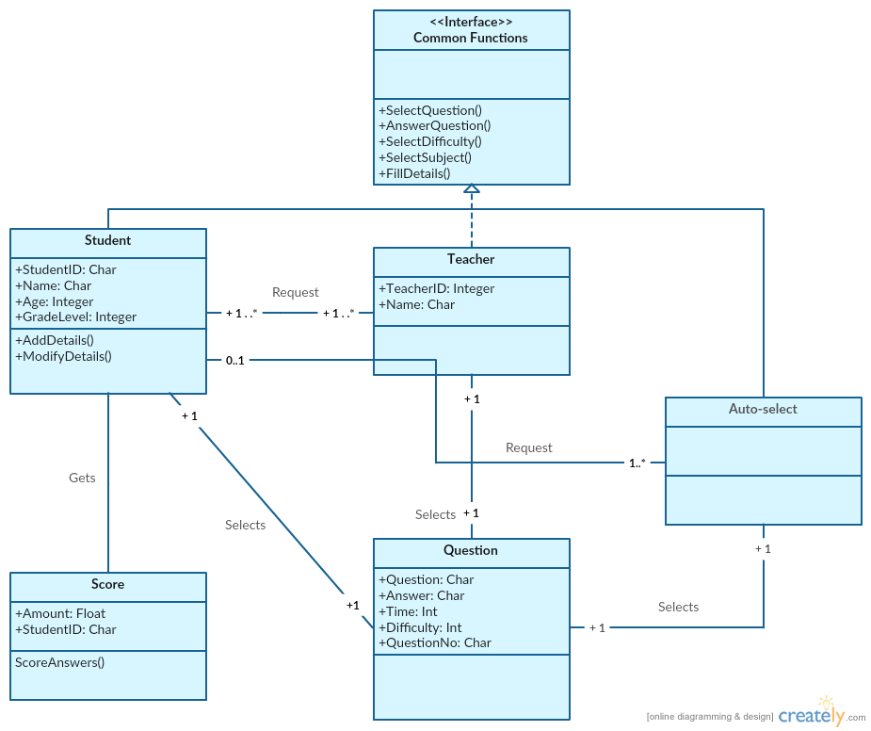

### Dynamic Model

Content

Include sequence diagrams of each use-case here. This is a first step towards identifying preliminary objects. ( If the sequence diagram would be too big to fit, then it can either be broken down into pieces or a communication diagram can be used in its place. )

Depending on the particular design, this section may also include finite state diagrams.

Motivation

Visual representation of use-cases and helps to identify objects and classes that we would need.

Considerations

We need to consider the administrative role that could be done by us by setting the product up for teachers or we could have the teachers play the administrative role.

Example

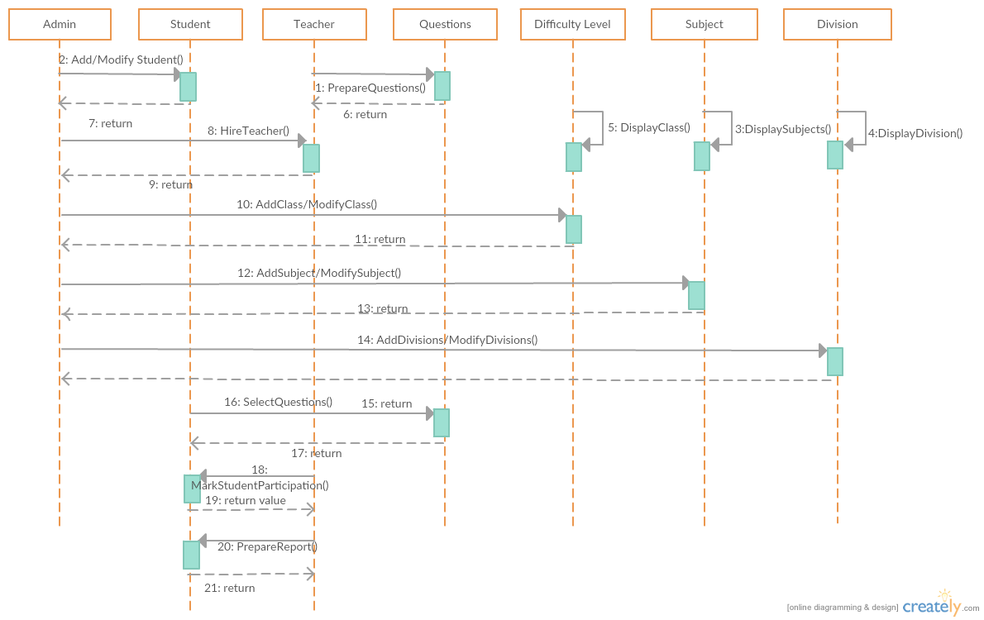

### Subsystem Decomposition

Content

Collection of classes, associations, operations, events and constraints that are closely interrelated with each other

Motivation

The Subsystem Decomposition will help with creating packages, so that our code is more organized.

Considerations

We have to consider the different packages we would like to create.

Example

An example with our product would be creating packages for the control of the student, the control of the teacher, and an overall administrative role

### Hardware / software mapping

Content

|  |
| --- |
| Hardware/software mapping describes how subsystems are assigned to hardware and off-the-shelf components. It also lists the issues introduced by multiple nodes and software reuse. |
|  |

Math through VR is a project under development and thus, has no existing hardware or software systems of its own, although the client is currently using a variety of hardware for everyday work.

The current system design for our application will need a high GPU machine and will consist of 2 monitors where the teacher can monitor the children's progress and the monitor will be use by user in to change lessons or to track the progress.

Motivation

The real consideration for this application will be use to save time and making the process more efficient and faster and hence we will use a Memento design pattern which will save the current state or data of the application when excited or unexpectedly shutdown.

To have a layout of the systems we will be using and developing with.

We have to consider the size of the virtual reality graphics and how these will require using a high graphic card, as well as taking up more space in memory.

Example

Example would be the games that we download from steam are just available for certain OS or has a GPU.

We have very high-definition graphics, so we need to use a computer with a fast processor, such as an i7, to develop.

### Data Dictionary

Content

To save the progress and the user data we will need a database that will in for our purpose will be MongoDB because we can save multiple different type of data.

Motivation

CConsiderations

Example

### Persistent Data management

Content

Persistent data management describes the persistent data stored by the system and the data management infrastructure required for it. This section typically includes the description of data schemes, the selection of a database, and the description of the encapsulation of the database.

Motivation

So that all our data is in place and saved.

Considerations

We could consider using cloud services. Also, will we be using open source database applications or paying for them?

Example

We will be using NoSQL Databases to store our information about user data.

### Access control and security

Content

|  |
| --- |
|  |
|  |

Access control and security describes the user model of the system in terms of an access matrix. This section also describes security issues, such as the selection of an authentication mechanism, the use of encryption, and the management of keys.

Motivation

To protect the development of our products and ensure the privacy of our employees and users.

Considerations

We have to consider what the graphic designers can see opposed to what the programmers can see and have access to.

Example

We have to consider what the graphic designers can see opposed to what the programmers can see and have access to.

### Global software control

Content

|  |
| --- |
| Global software control describes how the global software control is implemented. In particular, this section should describe how requests are initiated and how subsystems synchronize. This section should list and address synchronization and concurrency issues. |
|  |

Motivation

To ensure quality control of the functionality of our product.

Considerations

We have to consider the synchronization between the subsystems that we have made, such as the software from the teacher side and the student side and how they work together.

Example

We will have a subsystem for the teacher side of the product, and a student side, so there will be synchronization so that they can work together.

### Boundary conditions

Content

|  |
| --- |
| Boundary conditions describes the start-up, shutdown, and error behavior of the system. (If new use cases are discovered for system administration, these should be included in the requirements analysis document, not in this section.) |
|  |

Motivation

So we know when things are going wrong with start-up, shutdown, and other things.

Considerations

We have to consider having a fast start up time for our product.

Example

Start up should take no longer than 2 minutes.

Shut down should take no longer than 1 minute.

## Subsystem services

Content

|  |
| --- |
| Subsystem services, describes the services provided by each subsystem in terms of operations. Although this section is usually empty or incomplete in the first versions of the SDD, this section serves as a reference for teams for the boundaries between their subsystems. The interface of each subsystem is derived from this section and detailed in the Object Design Document. |

Motivation

Considerations

Example

## User Interface

Content

We are going to have a very simple but graphical UI design

Motivation

Our UI will be easy for children and educators to use

Considerations

We have to consider the appeal to children, and what will intrigue them about our product, such as the use of bright color, and large text, etc.

Example



## Object Design

### Object Design Trade-Offs

Content

Things to consider when thinking of one thing that might help the product but might hinder it in another way.

Motivation

To consider what is important to our product.

Considerations

Buy vs. Build

Memory Space vs. Response Time

Example

Our product will take up more memory space and might require external hard drives, but have better performance.

### Interface Documentation guidelines

Content

Motivation

Considerations

Example

### Packages

Content

A set of related [programs](https://www.collinsdictionary.com/us/dictionary/english/program) for a particular type of [task](https://www.collinsdictionary.com/us/dictionary/english/task) such as word [processing](https://www.collinsdictionary.com/us/dictionary/english/processing), sold and used as a [single](https://www.collinsdictionary.com/us/dictionary/english/single_1) unit

Motivation

To cluster related functionality together, so programming is more organized and structured.

Considerations

We have to consider the teacher and student role in our program.

Example

We will have a package for the teacher functionality and for the student functionality.

### Class Interfaces

Content

An interface in the Java programming language is an abstract type that is used to specify a behavior that classes must implement.

Motivation

To better structure our code and make for reuse.

Considerations

We have to consider the different types of data we will be dealing with.

Example

We will have an interface for the questionnaire portion of our product.

We will have a separate interface for the student actions and teacher actions.

# Test Plans

## Features to be tested / not to be tested

Content

Since we have a team of people working on this project, we will have to come up with technical requirements and design goals that we must discuss with the clients and also depending on the result of the usability testing that will be performed to help improve the product. The most initially step of designing a custom product is to set the requirements for the system goals and what machine and software drivers or hardware will be required to support the application.

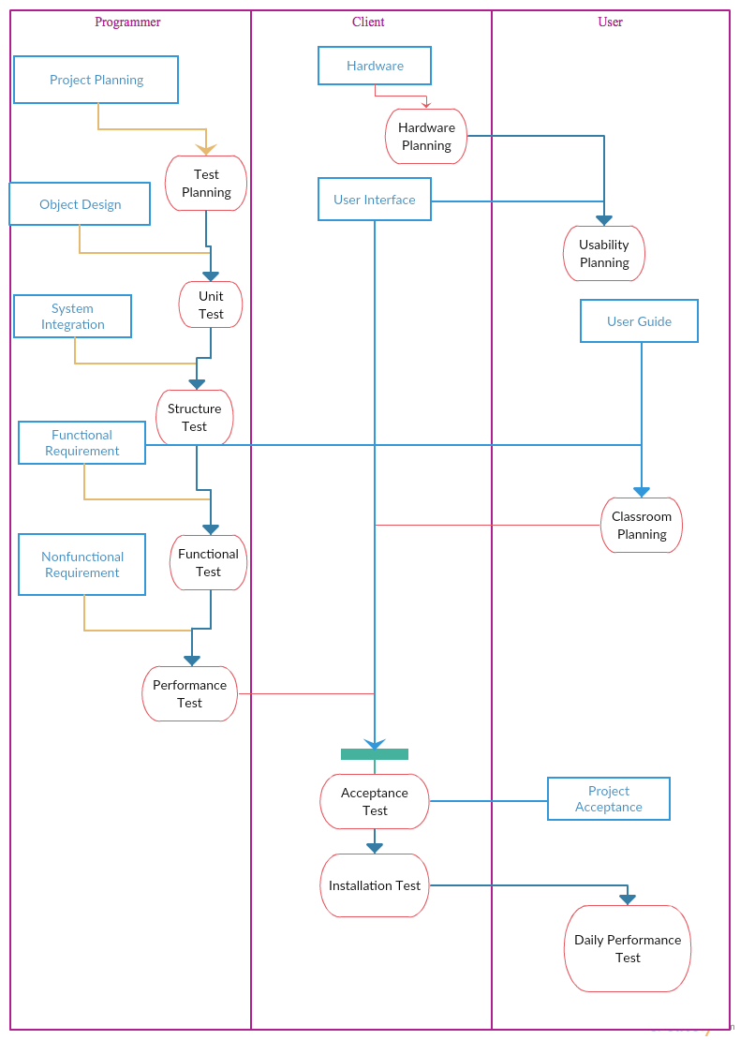

Motivation

Our motivation is to have a better product by testing what works, what doesn’t, and then coming up with changes to be made.

Considerations

We have to consider our clients’ needs and wants. What would teachers want in our product and why?

Example

The answering of questions will be tested by students and education experts.

The usability of the product will be tested by both educators and students.

## Pass/Fail Criteria

Content

This section deals with defining when an item has passed or failed. This is not the place to define the detailed pass criteria for each feature, but to describe the process and overall standards for evaluating the test results.

The pass or fail criteria of the testing will be

Motivation

To test our findings.

Considerations

We have to consider the importance of each test case, will some tests failing be more important than other tests passing.

Example

We will test our product usability and see if it passes by a checklist created by our team and education experts, we will ask things such as “Did you learn better using this product?” and “Did this work?” and “Did this not work?”

## Approach

Content

We will take a group approach where the programmer and client and the user can test depending on the test

Motivation

The test motivation for test is to make sure that the user and the client can have a good user experience and an uninterrupted experience.

Considerations

While test, we must consider that we are not interrupting their study session and maintaining the integrity of the data.

Example

Like we must conduct the usability test at the client’s location.

## Suspension and resumption

Content

Motivation

Considerations

Example

## Testing materials ( hardware / software requirements )

Content

Materials that we are going to use to test.

The hardware component for this application is the most important part and will be required to be tested at the client and by the user before they get started. Also, there will be safety precaution during the design and testing of the actual set-up.

## Test cases

Content

Trial scenarios that we are going to be used during the testing process.

Motivation

To properly test our product with likely options.

Considerations

We have to consider how well to train people about the product before selecting use cases.

Example

We will set up practice problems to be tested with.

## Testing schedule

Content

The schedule for testing our product.

Motivation

To stay organized and keep on track.

Considerations

We have to consider our time constraints.

Example

We will start out by testing the virtual reality system as a whole, then testing parts of our product, then the whole product, and then sending it out to be tested with teachers and children.

# Project Issues

## Open Issues

The application might have some issues with data and the different users that get added every school year. It also has issue with deleting data of old students who either finish the program or have graduated.

Content

It’s really important that the application is not to slow and due to the speed there might be some issues with the data but the manually backup should bring up the data as fast as possible.

Motivation

We will be backing up the data every day after school and every weekend to avoid as much loss of data as possible.

Examples

We will be asking teachers and other people in the education field for advice on our product, focusing on the overall design of it and we do not know what advice they will give us.

We will also be asking teachers which environments they will be comfortable setting up a VR setting in, so we can scale our product correctly.

Considerations

Are there any issues with the HTC Vive system or company that will impact our product? Will there be issues with Steam VR working with our product? Are there changes that might occur following the feedback received from the schools we are testing our product with?

## Off-the-Shelf Solutions

### Ready-Made Products

Content

We will be asking teachers and other people in the education field for advice on our product, focusing on the overall design of it and we do not know what advice they will give us.

We will also be asking teachers which environments they will be comfortable setting up a VR setting in, so we can scale our product correctly.

Motivation

Periodically backing up the data would be the best solution for the application and would also allow us to keep the application fast enough.

Considerations

We will be using HTC vive for the application which is already available in the market. For the operating system, the application is compatible with windows 7, 10 and also with OS X system . It will also be compatible with linux in the future.

### Reusable Components

Content

We can develop a framework that will include all the functions for virtual reality, such as working with sensors, moving graphics, etc. so that we can easily develop our product and make improvements as time goes on using the existing framework. We can also, reuse the exiting math games and implement them with our application.

Motivation

Reusing the previous framework will make the updates much easier and faster to do.

### Products That Can Be Copied

Content

We will be using open source games that are gear towards grade school students to help them learn math. We will also be using some built in libraries for the front end to and make changes on top of the library.

Motivation

We will be using some existing application program interface for math problems for the different levels and also reuse already existing educational games.

Examples

For our product, we can use educational video games or educational apps that are out there. The ideas can be further implanted and compiled into our product.

Considerations

Compiling the traditional education system with non-traditional games which are targeted towards little kids would be the best option to implement it. The kids are already used to those app games so it’ll be easier to get them engaged with the product.

## New Problems

### Effects on the Current Environment

Content

This application will be more interactive in comparison to the some educational games that already exist. Our application will allow the students to move things around and talk to the system. They also has audio that will talk to the students.

Motivation

We will be using some existing application program interface for math problems for the different levels and also reuse already existing educational games. Having an interactive application may cause some issues with the speed and the quality of the interactive audio.

### Effects on the Installed Systems

Content

To install the application the client has to dedicate a big enough room for the environment to fit. There will be a technician for setting up the environment for the first time. In terms of the software side of the application there will a CD or an online membership that the user will to install.

Motivation

To have the application completely running, the client will need to buy the hardware equipment and the glasses. For the software, the application can run on any of the new operating systems that are currently out there.

### Potential User Problems

Content

The application might have some issues with data and the different users that get added every school year. It also has issue with deleting data of old students who either finish the program or have graduated.

Motivation

We will structure our product to work on different computers, and test them using different processors and different operating systems to make sure these problems do not occur.

### Limitations in the Anticipated Implementation Environment That May Inhibit the New Product

Content

Statement of any potential problems with the new automated technology or new ways of structuring the organization.

Motivation

The intention is to make early discovery of any potential conflicts that might otherwise not be realized until implementation time.

We will keep track of all changes made and send them out to our testers.

### Follow-Up Problems

Content

Identification of situations that we might not be able to cope with.

Motivation

To guard against situations where the product might fail.

## Tasks

### Project Planning

Content

Details of the life cycle and approach that will be used to deliver the product. A high-level process diagram showing the tasks and the interfaces between them is a good way to communicate this information.

Motivation

To specify the approach that will be taken to deliver the product so that everyone has the same expectations.

We will have a large portion of our documentation given out to users that shows them what will work and what will not based on their operating systems and environments.

Considerations

Depending on the maturity level of your process, the new product will be developed using your standard approach. However, some circumstances are unique to a particular product and will necessitate changes to your life cycle. While these considerations are not product requirements, they are needed if the product is to be successfully developed.

If possible, attach an estimate of the time and resources needed for each task based on the requirements that you have specified. Attach your estimates to the events, use cases, and/or functions that you specified in sections 8 and 9.

Do not forget issues related to data conversion, user training, and cutover. These needs are usually ignored when projects set implementation dates.

We have to consider having a document on the cloud where we can all work together to document these things.

### Planning of the Development Phases

Content

Specification of each phase of development and the components in the operating environment.

Motivation

To identify the phases necessary to implement the operating environment for the new system so that the implementation can be managed.

Fit Criterion

Name of the phase.

Required operational date.

Operating environment components included.

Functional requirements included.

Nonfunctional requirements included.

## Migration to the New Product

### Requirements for Migration to the New Product

Content

A list of the conversion activities. Timetable for implementation.

Motivation

To identify conversion tasks as input to the project planning process.

### Data That Has to Be Modified or Translated for the New System

Content

List of data translation tasks.

Motivation

To discover missing tasks that will affect the size and boundaries of the project.

Fit Criterion

Description of the current technology that holds the data.

Description of the new technology that will hold the data.

Description of the data translation tasks.

Foreseeable problems.

## Risks (Done)

Biggest risk that we are taking is the assumption of investment from the customers for our products. Our product requires a separate room built and a space allocated for the use of such a device. This will mean for the customer to give us proper accommodation. Our risk is that, will they buy or invest in our product because of this.

Our next big risk will be making sure the UI interface works well with our customers and our base.

Our biggest risk will probably be low quality and low productivity, as this will affect the sales of our product the most.

## Costs

* + HTC Vive – Headset + Room sensors => $3500
    - Current market value of all products
    - HTC Vive - $799
    - Video Camera (x6) - $299 x 6 ~ $1,800
    - Video sensors (x2) - $500 ~ $1000
  + Project Documentation => $700-$3400
    - Documentation from consultants
  + Application Development => $50,000-$200,000
    - Salaries of developers, hardware and testing needed throughout process
  + Graphic Designs => $50,000-$100,000
    - Free lancers and graphic designers on payroll
  + Post production maintenance and system updates => $50/mo fee
    - Company determined price

## Waiting Room

Content

* 1. Expansion to higher level grades: This update will be an expansion towards those in higher level education. Middle school or High school. We want to incorporate a wider range of students
  2. Ability to expand to more subjects: Though our main focus for the first release in Math, we want to expand our product to subjects such as chemistry, biology, and even history. This will give students an edge in maintaining an interest in school and course grades.

## Ideas for Solutions

* 1. User functionality for grades: Create a reporting application add on that will enable the teacher or administrator of the lessons to be able to get a clean report from students on what they are learning and hoe they are faring.
  2. Easy to use UI: Target audience will be little kids and not tech savvy adults. This will require us to make a UI that is easy to use and navigate. This will require us to create prototypes and small UI desgins and get opinions from focus groups and their ease of use.
  3. Durability of product: As mentioned the target audience are mainly kids, so there needs to be a level of durability of the product. This can be solved by creating a protective casing or give a complementary one for the use of the school in storage and while in use.

## Project Retrospective

Content

Our method to break up our testing and work side by side with development helped us achieve a cleaner launch. Bugs were at a minimum and the user experience review really helped in out achieving the best possible product for the kids.

# Glossary

The glossary defines terms that may not be familiar to all readers. This is especially important if the document is expected to reach a wide and varied audience, such as school children. The glossary may be placed at either the beginning or the end of the document.

**Flotsam:** Any part of a ship or its cargo found floating on the water, whether it was deliberately or accidentally lost by its original owners.

**Jetsam:** Any part of a ship or its cargo that is deliberately cast off ( jettisoned ) by its original owners, generally in order to lighten the ship, whether it floats or sinks.

# References / Bibliography

This section describes the documents and other sources from which information was gathered. This sample bibliography was generated using the “Insert Citation” and “Bibliography” buttons in the “Citations & Bibliography” section under the “References” tab of MS Word. Creating new citations will not update this list unless you click on it and select “Update Field”. You may need to reset the style for this paragraph to “normal” after updating.

|  |  |
| --- | --- |
| [1] | Robertson and Robertson, Mastering the Requirements Process. |
| [2] | A. Silberschatz, P. B. Galvin and G. Gagne, Operating System Concepts, Ninth ed., Wiley, 2013. |
| [3] | J. Bell, "Underwater Archaeological Survey Report Template: A Sample Document for Generating Consistent Professional Reports," Underwater Archaeological Society of Chicago, Chicago, 2012. |
| [4] | M. Fowler, UML Distilled, Third Edition, Boston: Pearson Education, 2004. |

# Index

This section provides an index to the report. The sample below was generated using the “Mark Entry” and “Insert Index” items from the “Index” section on the “References” tab, and can be automatically updated by right clicking on the table below and selecting “Update Field”. To remove marked entries from the document, toggle the display of hidden paragraph marks ( the paragraph button on the “Home” tab ), and remove the tags shown with XE in { curly braces. }

Design 61, 65

Requirements 36, 53, 60

Test 66, 67

References:

<https://www.eonreality.com/solutions/augmented-virtual-reality-education/?gclid=CLDMiKf8ytMCFYyMaQodU3MBNQ>

<https://unimersiv.com/>

<http://www.arvrmagazine.com/vr-in-education-whats-already-happening-in-the-classroom/>